Faculty of Data Sciences

Ghulam Ishaq Khan Institute of Engineering Sciences and Technology, Topi

CS311L- Operating System Lab

Fall 2024

Lab No : 3

Lab Title : Grep, redirection and piping

Student Name : Muhammad Bilal

Registration No : 2022360

Submission Date : 5 oct, 2024

Submitted To : Maam Mah Rukh

Task 1:

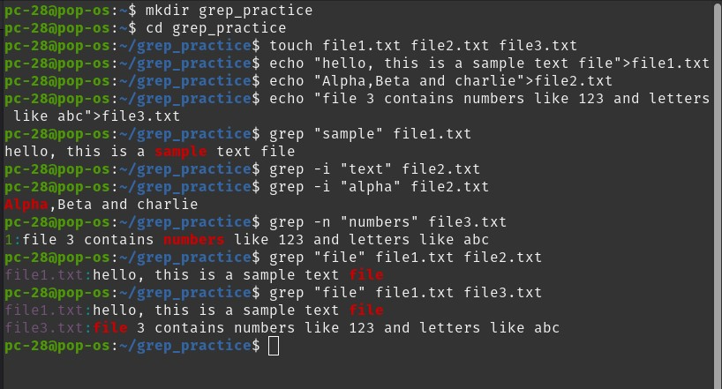

Task 2:

Task 3:

Task 4:

